Setting 1: perfect surrogate
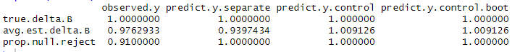
Setting 2: imperfect surrogate
Setting 3: not a surrogate, but there is a treatment effect
Setting 4: S is useless, no overall treatment effect
Setting 5: S is a “surrogate” in that it predicts Y, but no treatment effect

